Multiple-choice section

|  |  |  |  |  |  |  |  |  |
| --- | --- | --- | --- | --- | --- | --- | --- | --- |
| Question | 1 | 2 | 3 | 4 | 5 | 6 | 7 | 8 |
| Answer | C | B | C | C | A | C | C | D |

Question 1 [1.1]

C



Question 2 [1.2]

B

m = 

= 

Question 3 [1.2]

C



Gradient =  y-intercept = -3

Question 4 [1.3]

C



Question 5 [1.4]

A

The line with equation  has the gradient of .

The line with equation  can be expressed as , which has a gradient of .  
These lines are parallel.

Question 6 [1.4]

C

The gradient of the line  is .

The line with equation  can be expressed as ****, which has a gradient of 4.  
The lines are perpendicular line because:

4 × - = -1

Question 7 [1.5]

C



So x =  is not a solution.

Question 8 [1.6]

D

Substitute y = -2x + 6 into 2y + 6x = 7.

2(-2x + 6) + 6x = 7

-4x + 12 + 6x = 7

2x + 12 = 7

2x = -5

x = -2

Substitute x = -2 into y = -2x + 6,

y = -2 × -2 + 6 = 11

x = -2, y = 11

Multiple-choice total marks: 8

Short answer section

Question 9 11 marks [1.2]

(a) Lines that are parallel have the same gradient.

(b) Lines that are perpendicular meet each other at an angle of 90°.

(c) A linear relationship exists between two variables when the graph of the relationship is a straight line.

(d) A linear relationship is described by a linear equation.

(e) The general equation of a straight line is , where m is the gradient of the line and  is the y-intercept of the line.

(f) A linear equation has one solution and a linear inequality has a range of solutions according to the inequality.

(g) Linear equations can be solved by applying inverse operations to both sides of the equation.

(h) The gradient of a line is a measure of its steepness, which can be evaluated by evaluating the fraction rise over run.

Question 10 3 marks [1.1]



Question 11 4 marks [1.1]



Question 12 2 marks [1.2]



Question 13 2 marks [1.3]

y = -1x – 2

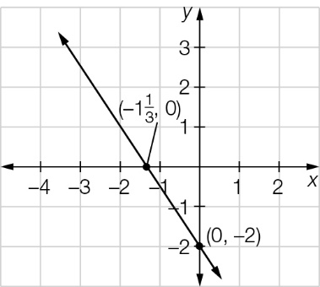

Question 14 4 marks [1.4]

(a) The equation  can be expressed as .  
The lines  and  have the same gradient so they are parallel.

(b) The equation  can be expressed as y = -1x + 5 so that it’s gradient is -1, and the equation  can be expressed as  so that it’s gradient is .   
The product of their gradients is -1, ( × - = -1) so the lines are perpendicular.

Question 15 4 marks [1.5]

(a) 3x – 1 ≥ -16  
3x ≥ -15  
x ≥ -5

(b) -5x – 3 < 12  
-5x < 15  
x > 3

Question 16 3 marks [1.5]

2(3x + 4) ≥ 2x – 8

-6x + 8 ≥ 2x – 8

-8x ≥ -16

x ≤ 2

Question 17 4 marks [1.6]

y = 2x +3

4x – y = -2

Using substitution:





Question 18 4 marks [1.6]



Short answer total marks: 41

Extended answer section

Question 19 7 marks [1.2, 1.3, 1.4]

(a) 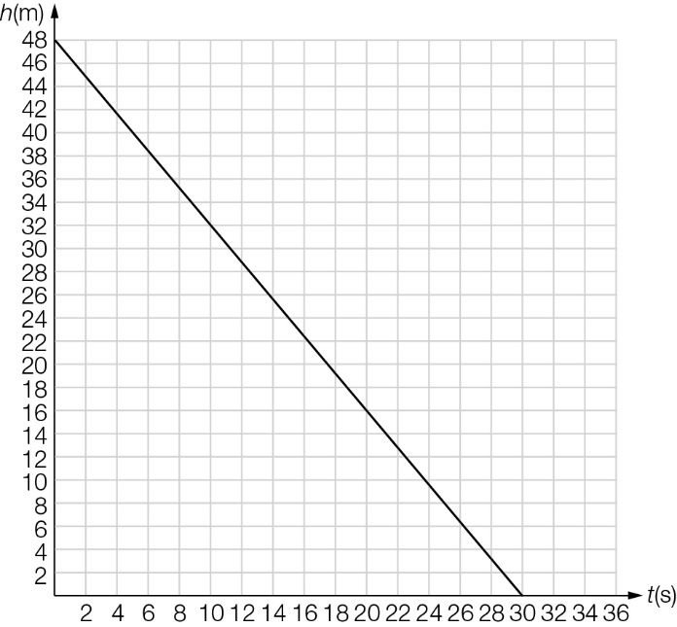

(b) Gradient = , hence rate of descent is .

(c) 

(d) The elevator is 48 m high.

Question 20 10 marks [1.2, 1.3, 1.4]

(a) 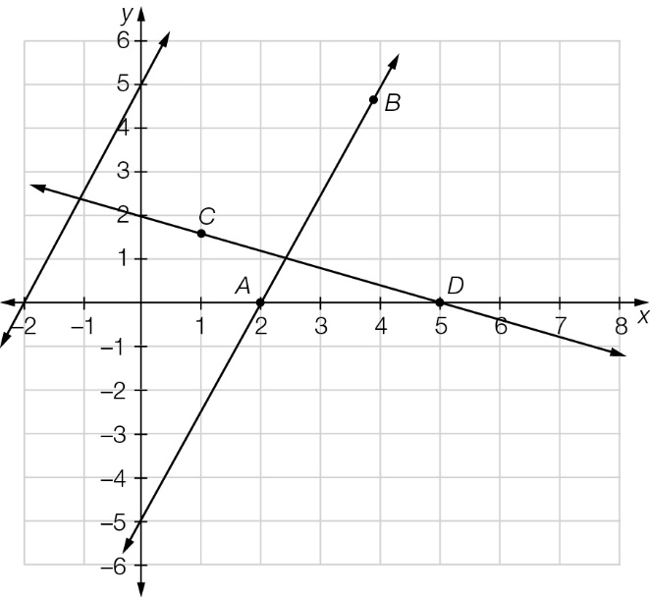

(b) (i) Equation of the line AB is .

(ii) The gradient of both lines is  so they are parallel.

(c) (i) Equation of the line CD is y = -x + 2

(ii) The product of the gradients is -1 (- ×  = -1) so they are perpendicular.

Question 21 5 marks [1.6]

Let each hockey stick cost H and each hockey bag cost B.

2H + 3B = 473.98 [1]

H + B = 177.99 [2]

2H + 2B = 355.98 2 × [2]

B = 473.98 – 355.98   
 B = 118

H + B = 177.99

H = 177.99 – 118   
 H = 59.99

Hockey sticks cost $59.99 and hockey bags cost $118.

Question 22 3 marks [1.1]

Let the first odd number be x.

The five odd numbers are: 



The numbers are 113, 115, 117, 119, 121.

Question 23 6 marks [1.1, 1.6]

(a) x + y = 30  
3x + 4y = 100

(b) x + y = 30 [1]  
3x + 4y = 100 [2]  
4x + 4y = 120 [1] × 4  
 x = 20 [1] × 4 – [2]  
Now substitute this value into [1]:  
20 + y = 30  
y = 10  
There are 20 3-mark questions and 10 4-mark questions.

(c) 15 × 2-mark questions and 0 × 3-mark questions  
12 × 2-mark questions and 2 × 3-mark questions  
9 × 2-mark questions and 4 × 3-mark questions  
6 × 2-mark questions and 6 × 3-mark questions  
3 × 2-mark questions and 8 × 3-mark questions  
0 × 2-mark questions and 10 × 3-mark questions

Question 24 9 marks [1.5]

(a) The other two sides will have a sum greater than 10 cm.

(b) x – 4 < 4 + x + 3  
x + 3 < 4 + x – 4  
4 < x – 4 + x + 3

(c) x – 4 < 4 + x + 3:  
x – 4 < 7 + x  
-4 < 7  
x + 3 < 4 + x – 4:  
x + 3 < x  
3 < 0  
4 < x – 4 + x + 3:  
4 < 2x – 1  
5 < 2x  
-4 < 7; 3 < 0; 5 < 2x

(d) The triangle is impossible with those dimensions because 3 < 0 is a false statement.

(e) x + 5 < x + 1 + x + 2  
x + 5 < 2x + 3  
-x < -2  
x > 2  
x + 1 < x + 2 + x + 5  
x + 1 < 2x + 7  
-x < 6  
x > -6  
No, there are more than one possible triangle. Using whole numbers x could be 3, 4, 5, … giving side lengths of 4, 5, 8 or 5, 6, 9, or 6, 7, 10, …

(f) x + 1 is the shortest side, so this gives   
x + 1 = 5  
x = 4  
This triangle is 5 cm, 6 cm and 9 cm.

Extended answer total marks: 40

TOTAL test marks: 89